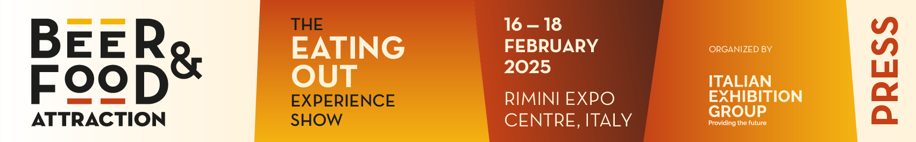

press release
(English translation)

BEER&FOOD ATTRACTION 2025 LANDS IN RIMINI WHERE
THE BAR & BEVERAGE INDUSTRY HAS PLANTED ROOTS

- Present at the opening ceremony, Alessandra Locatelli, Minister for Disabilities, and Mirco Carloni, President of the Agriculture Committee in the Chamber of Deputies.

- Until February 18, the 10th edition of the Italian Exhibition Group event will feature over 600 exhibitors, 1,217 brands, and 130 buyers from 47 countries. On display, a wide range of innovations, from 3D ice sculptures for cocktails to cactus water drinks.

- IEG President Maurizio Ermeti unveiled a preview of the 2026 novelty: Mixology Attraction, a full-fledged show that will join Beer&Food Attraction.

beerandfoodattraction.it | bbtechexpo.com

Rimini(Italy), 17 February 2025 – The 10th edition of Beer&Food Attraction, a B2B event curated by Italian Exhibition Group for the entire Bar&Beverage industry, was inaugurated yesterday at Rimini Expo Centre. Running until Tuesday, February 18, the expo halls will showcase a diverse range of offerings, including high-quality beverages, top Italian and international breweries, soft drinks, and mixology. These will be paired with a variety of food options, from casual dining to aperitifs, providing a comprehensive selection of products and services for the foodservice channel.

INTRODUCING THE 2026 PREVIEW: MIXOLOGY ATTRACTION
The opening ceremony's theme, “Quality, Trends, Innovation: Tomorrow's Horeca”, sets the stage for a forward-looking event. Speakers included Alessandra Locatelli, Minister for Disabilities, Mirco Carloni, President of the Agriculture Committee at the Chamber of Deputies, Emma Petitti and Alice Parma, Councillors of the Emilia-Romagna Region, and Juri Magrini, Councillor for Budget and Economic Activities of the Municipality of Rimini. The speakers included Antonio Portaccio, President of Italgrob, Alfredo Pratolongo, President of Assobirra, Vittorio Ferraris, President of Unionbirrai, Rocco Pozzulo, President of FIC- Italian Federation of Chefs, and Aldo Mario Cursano, National Vice President of FIPE- Italian Federation of Public Establishments. Maurizio Ermeti, President of Italian Exhibition Group, had the pleasure of hosting the event. (N.B.: For statements, please refer to the separate press release.) In his speech, Mr. Ermeti unveiled a preview of the big news for 2026: Mixology Attraction, a standalone trade show that will take pride of place alongside Beer & Food Attraction.
The ceremony concluded with the presentation of the Lorenzo Cagnoni Award, in partnership with ANGI - National Association of Young Innovators and ICE Agency, recognising the most innovative ideas in the Out of Home industry.

AMONG THIS YEAR’S NEW ENTRIES, 4D ICE SCULPTURES FOR COCKTAILS AND THE LOW-ALCOHOL PHENOMENON
This year, Beer&Food Attraction spotlights the most exclusive Italian cocktail bars (and a renowned Barcelona venue), all gathered at the Expo Centre to share the future of the mixology world. Not to be missed, the collection of ice sculptures, crafted with 4D technology, used in the bar world. With the growing “low-alcohol” offer: from beer to gin, and not forgetting the ubiquitous spritz, visitors can explore the latest trends. And then there are the low-calorie beers and cactus water-based drinks, which harness the nutritious and antioxidant properties of the succulent plant. When it comes to beers, visitors are spoiled for choice: Habanero pepper, grape must... to name but a few.

THE FUTURE OF HORECA TAKES TO THE ARENAS
The event is elevated by several arenas, authentic stages dedicated to talks, competitions, and high-level content, including:
Horeca Arena (Hall C3) hosts the 14th edition of the International Horeca Meeting by Italgrob, with a rich programme of talks and workshops in collaboration with all the associations in the supply chain and research companies, such as The European House Ambrosetti, Circana, Trade Lab, and Formind. The highlight of IHM will be the Congress "Out-of-Home: Eating out: Time for Change!” Policies and strategies for a sustainable recovery", scheduled for tomorrow, Monday, February 17, at 10:30 AM in the Neri Hall.
Mixology Circus (Hall C1): An area dedicated to the world of mixology, featuring 11 exceptional cocktail bars, masterclasses, and talks. This year’s new feature is the "Mixology Village," which brings together producers of spirits and accessories for bartenders, along with the "Sparkling&Mix" area, spotlighting to the best sparkling wine options for mixing.
Fic Arena (Hall A3) hosts the 9th edition of the Italian Cuisine Championships of FIC - Italian Federation of Chefs, with 500 competitors involved. New for 2025: the Global Chefs Challenge - European Gran Prix 2025, a high-level European cooking selection event that prepares participants for the Worldchefs world championship.

ABOUT BEER&FOOD ATTRACTION 2025
Date: 16 – 18 February 2025; Organiser: Italian Exhibition Group SpA; edition: 10th; recurrence: annual; info: https://www.beerandfoodattraction.it/

ABOUT BBTECH EXPO 2025
Date: 16 – 18 February 2025; Organiser: Italian Exhibition Group SpA; edition: 7th; recurrence: annual; info: https://www.bbtechexpo.com/

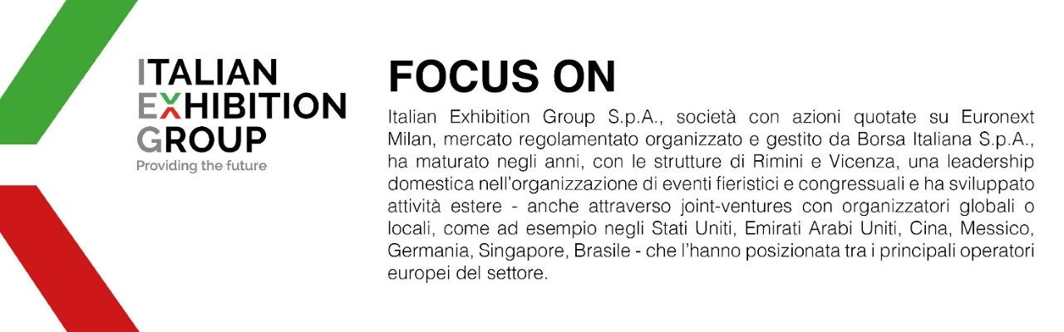

PRESS CONTACT ITALIAN EXHIBITION GROUP
Head of media relation & corporate communication: Elisabetta Vitali; press office manager: Marco Forcellini, Pierfrancesco Bellini; press office coordinator: Luca Paganin; press office specialist: Mirko Malgieri;
international press office coordinator: Silvia Giorgi; media@iegexpo.it

MEDIA AGENCY MEDIA AGENCY BEER&FOOD ATTRACTION-BBTECH EXPO: Mind The Pop - Martina Vacca: martina@mindthepop.it, mob. +39 339 748 5994; Fabrizio Raimondi: fabrizio@mindthepop.it, mob. +39 335 389 848; Stefano Chiossi: stefano@mindthepop.it, mob. + 39 388 739 4358.
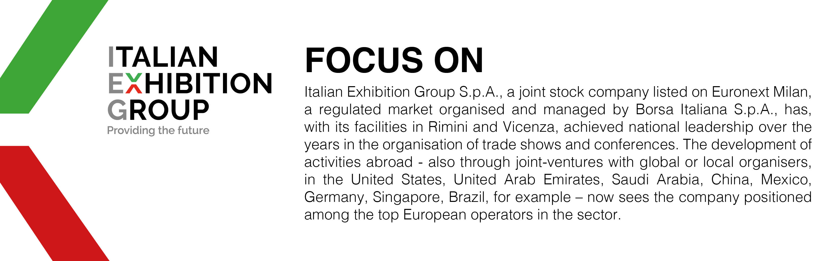

This press release contains forecast elements and estimates that reflect the management’s current opinions (“forward-looking statements”), particularly regarding future management performance, realization of investments, cash flow trends and the evolution of the financial structure. For their very nature, forward-looking statements have a component of risk and uncertainty, as they depend on the occurrence of future events. The effective results may differ (even significantly) from those announced, due to numerous factors, including, only by way of example: food service market and tourist flow trends in Italy, gold and jewellery market trends, green economy market trends; the evolution of raw material prices; general macroeconomic conditions; geopolitical factors and evolutions in the legislative framework. Moreover, the information contained in this release does not claim to be complete, and has not been verified by independent third parties. Forecasts, estimates and objectives contained herein are based on the information available to the Company as at the date of this release.

